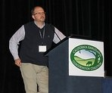
10th Annual Summit
“Collaborative Conservation for Rangelands”

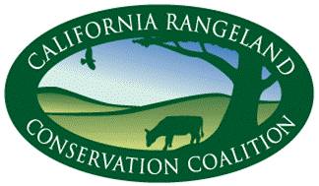
Update Summer, 2015

Summer 2013
Working together to keep ranchers ranching
With generous support of numerous Sponsors, the Coalition hosted the February 3 Summit for Coalition Signatories and guests to build relationships among rangeland stakeholders and facilitate learning from one another. It was held in conjunction with the Annual Meeting of the Society for Range Management (SRM). More than 200 ranchers (22%), agriculture and conservation organizations members and staff (25%), agency staff (38%), academics/students (11%) and others participated. Rangeland decision-makers who attended the Summit are responsible for 16+Million acres!
To address the theme Summit speakers from other rangeland alliances and disciplines shared their experiences, successes and challenges of collaborative conservation initiatives across the US. Nathan Sayre, UC Berkeley; Robin Reid, Center for Collaborative Conservation, CO State University; Bill McDonald, Malpai Borderland Group; Avery Anderson, Quivira Coalition; Laurel Marcus, Fish Friendly Ranching Program; Jim Stone, Blackfoot Challenge; Pelayo Alvarez, CA Rangeland Conservation Coalition; Leslie Allison, Western Landowners Alliance; and Dina Moore, Partners for Conservation. Their presentations are available on the CRCC website, and links to their organizations.
The Coalition is very grateful to many Sponsors! There were 19 ranch sponsorships. (See page 2.)
Here’s what the 2015 Summit participants told us.
“Extraordinary speakers sharing outstanding efforts made by people who understand the significance of land, soil, plants, human and animal interaction.” “Nice diversity of content and nice balance of science, academia, ranchers, and advocacy groups.” “Keep up the great work.” “I get a lot out of summits. Thank you for all you do for us.”
Progress Notes
- CRCC will be meeting with the new California State Parks leadership to continue discussion about reinstating grazing onto park lands with pilot projects.
- CRCC staff and signatories attended Rustici Symposium where rangeland watershed research, education and ranch planning efforts were recognized as part of the Grazing Regulatory Action Project (GRAP) discussions.
- CRCC staff and signatories attended California Climate and Agriculture Network’s Summit and participated in the rangeland panels.
- CRCC’s Alameda County and Contra Costa County Wildlife-friendly Livestock Pond Initiative is progressing on its fundraising and pond restoration goals.
- Pelayo Alvarez, former CRCC Director of Conservation is now teaching at Sacramento State and advising his rangeland business clients. Thank you, Pelayo for many years of Coalition leadership, rangeland expertise, and efforts to Keep Ranchers Ranching.

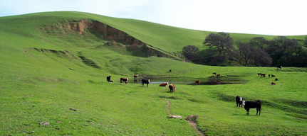
We’re returning to our roots in September!
The Coalition will celebrate its 10th Anniversary in Sunol, the backdrop for a meeting of environmentalists, ranchers and resource professionals from federal and state agencies. At this meeting of former foes in the summer of 2005, participants drafted a resolution documenting common ground for the conservation of the rangeland. Read Our Story on the website, and the Rangeland Resolution produced from that meeting. Watch for Anniversary information and stories in E-update.

STEERING COMMITTEE.

Vicky Dawley,Co-Chair, Tehama Resource Conservation District
Mark Rockwell, Co-Chair, Endangered Species Coalition
Bill Rankin,California Cattlemen’s Association (CCA)
Bill Sanguinetti,CCA
Carissa Rivers, Audubon California
Casey Stone, California Farm Bureau Federation
CeCi Dale-Cesmat, Natural Resources Conservation Service
Dan Macon, California Wool Growers Association
Dave Forrest,Institute for Ecological Health
Joan Keegan, Sierra Nevada Conservancy
John Kleinfelter, California Dept. of Fish and Wildlife
Justin Oldfield, California Cattlemen’s Association
Karen Buhr, California Assoc. of Resource Conservation Districts
Kim Delfino,Defenders of Wildlife
Lesa Carlton, California Woolgrowers Association
Mark Kramer,The Nature Conservancy
Matt Hamman, US Fish and Wildlife Service
Michael Delbar,California Rangeland Trust
Pablo Garza,The Nature Conservancy
Pat Kirby, California Cattlemen’s Association
Noelle Cremers, California Farm Bureau Federation
Renata Brillinger, California Climate Agriculture Network
Robert Parkhurst, Environmental Defense Fund
Sheila Barry, University of California Cooperative Extension
Tom Hedt, Natural Resources Conservation Service
Bre Owens,Point BlueConservation Science
Pelayo Alvarez
Conservation Director
pelayo@carangeland.org

The California Rangeland Conservation Coalition builds relationships that promote rangelands and private ranching through outreach and education, participation in research, and facilitation of conversations to reduce barriers to ranching and conservation and to make new opportunities to achieve the goals of the Rangeland Resolution.

2015 Summit Sponsors – Thank you!

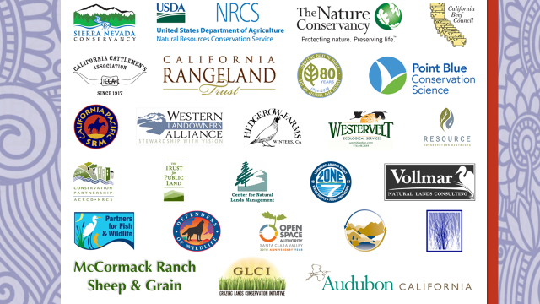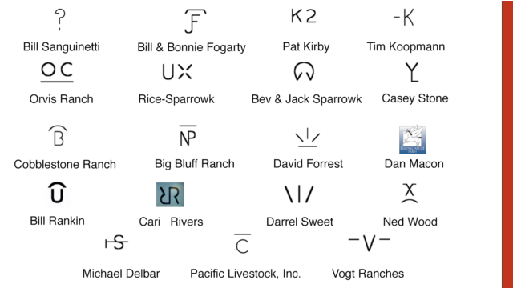

On Ranch Conservation Tour – Cattle, Conversation and Community, Too
A small group of conservationists joined Point Blue Conservation Science and California Rangeland Conservation Coalition to tour four Northern California ranches that are engaged in multi-benefit collaborative conservation projects. Through discussions with landowners and numerous speakers, participants from various conservation groups gained valuable insights into the opportunities and challenges of ranching with conservation in mind. Speakers included: Burt Bundy; Tony Turri; Joe Silveira, Wildlife Biologist, U.S. Fish & Wildlife; Larry Forero, UC Cooperative Extension; Kathy DeForest; Aaron Albaugh; Russ Hawkins, a private timber operator; Todd Swickard; Jack Hanson; Tim Koopmann; Ken Collum, Bureau of Land Management; Mark Shaffer, Greenleaf Power; and Bre Owens.
These ‘tourists’ traveled over 300 miles together through four counties, enjoying two days and 3 nights of home-cooked meals and lodging provided by ranchers. Tour sponsors included Fall River/Big Valley, Intermountain, and Lassen Cattlemen and CattleWomen, Lassen Land and Trails Trust, Abernathy Ranch, Willow Creek Ranch, DeForest Livestock, Cobblestone Ranch and many ranch hosts and speakers.
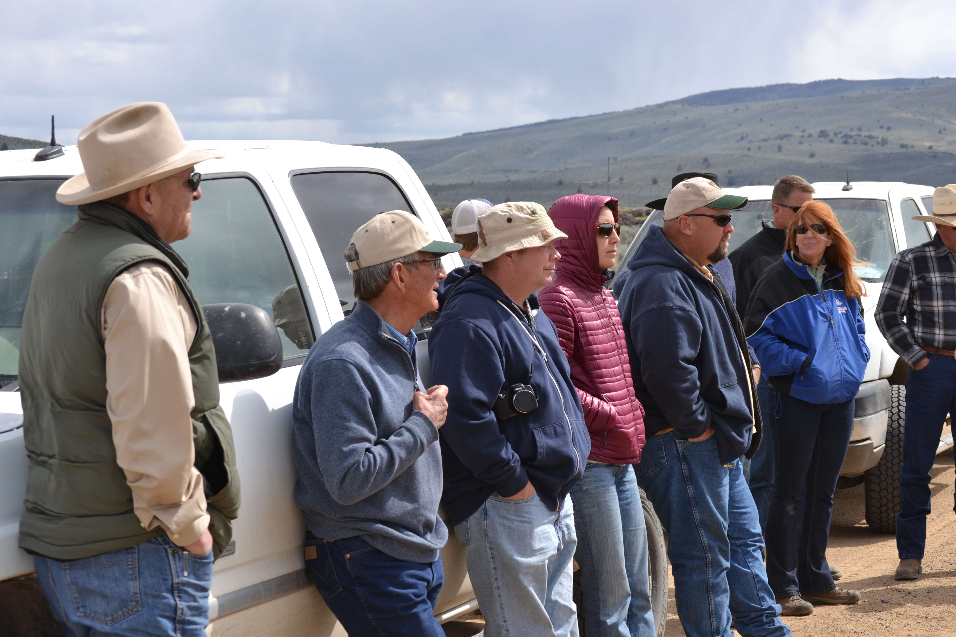
Tour participants agreed that ranchers and other rangeland stakeholders need to talk together more about these and other complex issues that impact ranching viability and voluntary conservation efforts. “Point Blue and CRCC are leaders in filling this void by fostering communication between consumers and producers with conservation being one of the important common threads,” said Todd Swickard, Five Dot Ranch. Bruce Ross, District Director for Assemblyman Brian Dahle learned a lot “through the sidebar conversations as people with common interests got to meet.” Tim Koopmann, Koopmann Ranch also emphasized the need for these opportunities - and for the California Rangeland Conservation Coalition.
The main takeaways for the non-ranchers were a better understanding of the complexities of ranching and conservation, and a heightened respect for the ranching community itself. They expressly want to learn more about ranching and about the ranching community. CRCC is interested in conducting other tours in cooperation with its Signatories to achieve these outcomes for other non-ranchers.
KEEP CURRENT ON RANGELAND NEWS!
www.carangeland.org
- Subscribe online to the bi-monthly E-Update for current events from the Coalition and its Signatories. Submit content about your rangeland activities. There are 1700+ subscribers, and 33% read each issue (a high readership)!
- “Friend” us on Facebook: I Love California Rangeland
- Contact Coalition Administrator, Karen Sweet - ksweet@cattlemen.net

