On Ranch Conservation Tour – Cattle, Conversation and Community, Too
A small group of conservationists joined Point Blue Conservation Science and California Rangeland Conservation Coalition to tour four Northern California ranches that are engaged in multi-benefit collaborative conservation projects. Through discussions with landowners and numerous speakers, participants from various conservation groups gained valuable insights into the opportunities and challenges of ranching with conservation in mind. Their main takeaways were a better understanding of the complexities of ranching and conservation, and a heightened respect for the ranching community itself.
These ‘tourists’ traveled over 300 miles together through four counties, enjoying two days and 3 nights of home-cooked meals and lodging provided by ranchers. Tour sponsors included Fall River/Big Valley, Intermountain, and Lassen Cattlemen and CattleWomen, Lassen Land and Trails Trust, Abernathy Ranch, Willow Creek Ranch, DeForest Livestock, Cobblestone Ranch and many ranch hosts.
Tuesday evening began with dinner hosted by Cobblestone Ranch and a presentation by Tehama County Supervisor, Burt Bundy, who also serves on the Los Molinos Mutual Water Company board and is President of the Mill Creek Conservancy. He focused on the various issues facing the water company, its customers and Mill Creek, including drought, open-ditches and outdated infrastructure, pulse-flow requirements and state-mandated water curtailments just to list a few. After dinner, some participants bottle fed baby lambs.
On Wednesday the group visited the Sacramento River National Wildlife Refuge near Corning. Joe Silveira, Wildlife Biologist, U.S. Fish & Wildlife Service explained how “the refuge uses livestock grazing to improve wildlife habitat, reduce weeds and thatch buildup, maintain native grasses, enhance native wildflowers reduce hazardous fuels, and maintain flood flows.” He works with Tony Turri and other cattle and sheep ranchers to achieve these refuge goals, and Tony shared his management to achieve them.
Overlooking Mt. Shasta and Mt. Lassen at Abernathy Ranch Point Blue explained its Rangeland Watershed Initiative, a partnership with Natural Resource Conservation Service focused on re-watering California’s rangelands. Further, the Rangeland Monitoring Network provides tools, data, and people that assist ranchers, researchers, and conservation planners and partners in collecting data that expands California’s rangelands knowledge. In Redding Larry Forero, University of California Cooperative Extension presented a cattle industry overview that also explained the connection of the Central Valley and mountain ranching.
The Fall River/Big Valley Cattlemen and Intermountain CattleWomen hosted the group for a barbecue dinner in Adin. Conversation included the legislative and enforcement issues of legal and illegal marijuana growing and impacts on the personal safety of those working in the forests. At DeForest Livestock the next morning, participants observed what can happen when ranchers, conservationists, and agencies collaborate. The group walked along a restored riparian area on the ranch that provides habitat for the Modoc sucker, a native fish endemic to the Pit River and its tributaries. The sucker is soon to be “de-listed” due to successful recovery efforts initiated by local ranchers and conservation partners. An informative conversation followed about wolves and their expected return to California. Kathy Deforest explained some of the logistics of ranching with a predator presence, and others shared Big Valley’s experience with the collared wolf, OR-7. Discussion revolved around efforts amongst ranchers and conservation partners to prepare for successful co-existence. Inside DeForest’s living room Russ Hawkins, a private timber operator explained the area’s timber industry and the challenges of catastrophic wildfire, wildlife habitat, regulations, managing for endangered species, and the impacts on community dynamics. Kathy served a hot beef sandwich lunch.
At Willow Creek Ranch near Susanville the group heard from ranchers Jack Hanson, Dennis Wood and Todd Swickard and from Ken Collum, Bureau of Land Management about the challenges of managing ranches and sagebrush ecosystems to benefit native species, such as the Greater sage-grouse (a candidate species under the federal Endangered Species Act). Two major concerns discussed were juniper encroachment and the negative impact of feral horses on springs and riparian areas, on which Greater sage-grouse depend during the critical chick rearing stage. Mark Shaffer, Greenleaf Power described the biofuel industry’s challenges to use the juniper chips from the removal efforts. Lassen County Cattlemen and CattleWomen and the Lassen Land and Trails Trust hosted the group for a social time and dinner. Tim Koopmann, immediate past president of California Cattlemen’s Association, explained the current status of the Grazing Regulatory Action Plan being proposed by the State and Regional Water Quality Control Boards.
Tour participants agreed that ranchers and other rangeland stakeholders need to talk together more about these and other complex issues that impact ranching viability and voluntary conservation efforts. “Point Blue and CRCC are leaders in filling this void by fostering communication between consumers and producers with conservation being one of the important common threads,” said Todd Swickard, Five Dot Ranch. Bruce Ross, District Director for Assemblyman Brian Dahle learned a lot “through the sidebar conversations as people with common interests got to meet.” Tim Koopmann also emphasized the need for these opportunities - and for the California Rangeland Conservation Coalition. The ‘tourists’ want to learn more about the cattle industry, its issues and the cattle community.
Contact: Bre Owens, 530-514-3107

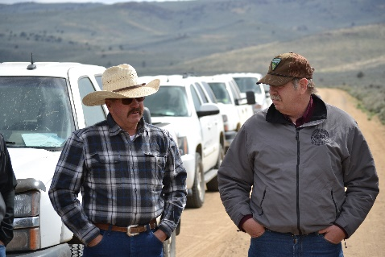
Dennis Wood, Rancher and Jim Kenna, Bureau of Land Management in Lassen County

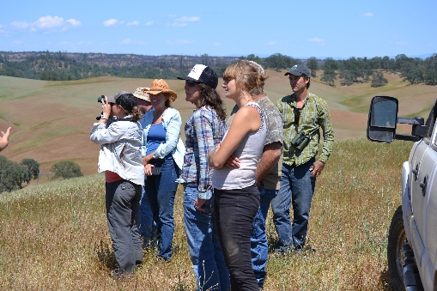
Conservation ‘tourists’ in Western Tehama County

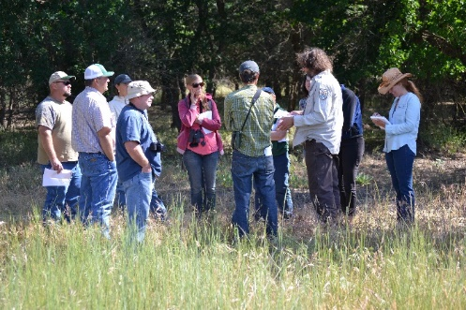
Learning about the multiple benefits of livestock grazing at Sacramento Wildlife Refuge with Tony Turri
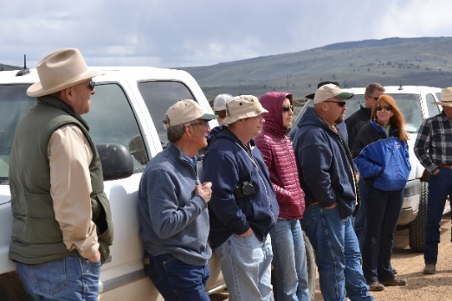

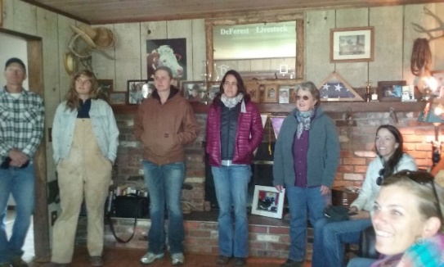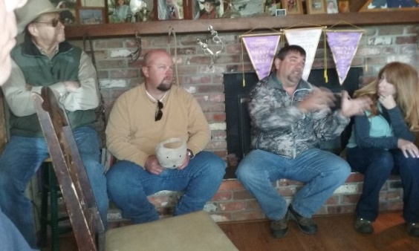
Talking about rural communities, forestry, ranching and wildlife management and recovery.

