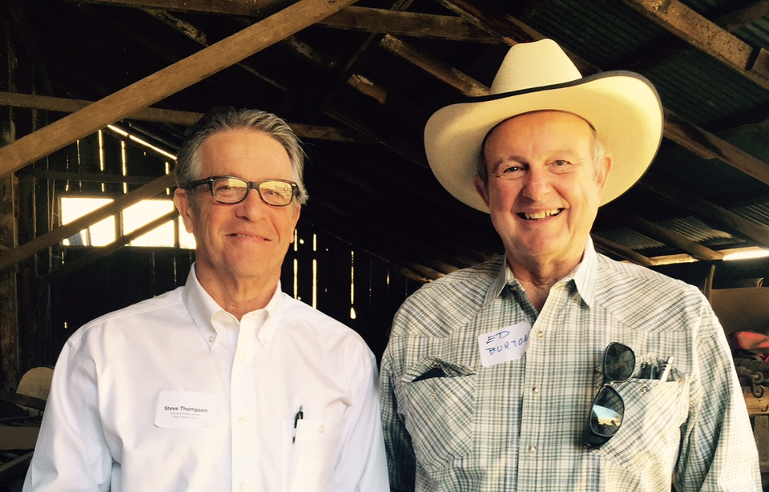
Rangeland Summit
“ ”

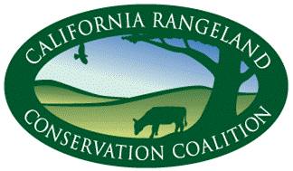
Update January, 2016

Summer 2013
Working together to keep ranchers ranching
With the generous partnership of University of California Agriculture and Natural Resources and support of numerous Sponsors, the Coalition hosts the 2016 Summit for Coalition Signatories and guests to build working relationships and greater understanding among rangeland stakeholders and facilitate learning from one another.

Working Together
- CRCC’s Alameda County and Contra Costa County Wildlife-friendly Livestock Pond Initiative is progressing well on its fundraising and pond restoration goals. data
Restored POND PHOTO
- Summit summary as given to committee – data,
What Summit participants tell us
“Extraordinary speakers sharing outstanding efforts made by people who understand the significance of land, soil, plants, human and animal interaction.” “Nice diversity of content and nice balance of science, academia, ranchers, and advocacy groups.” “Keep up the great work.” “I get a lot out of summits.” “Thank you for all you do for us.”
- Tours
- E-update and Facebook data, how subscribe

Message from the Chair 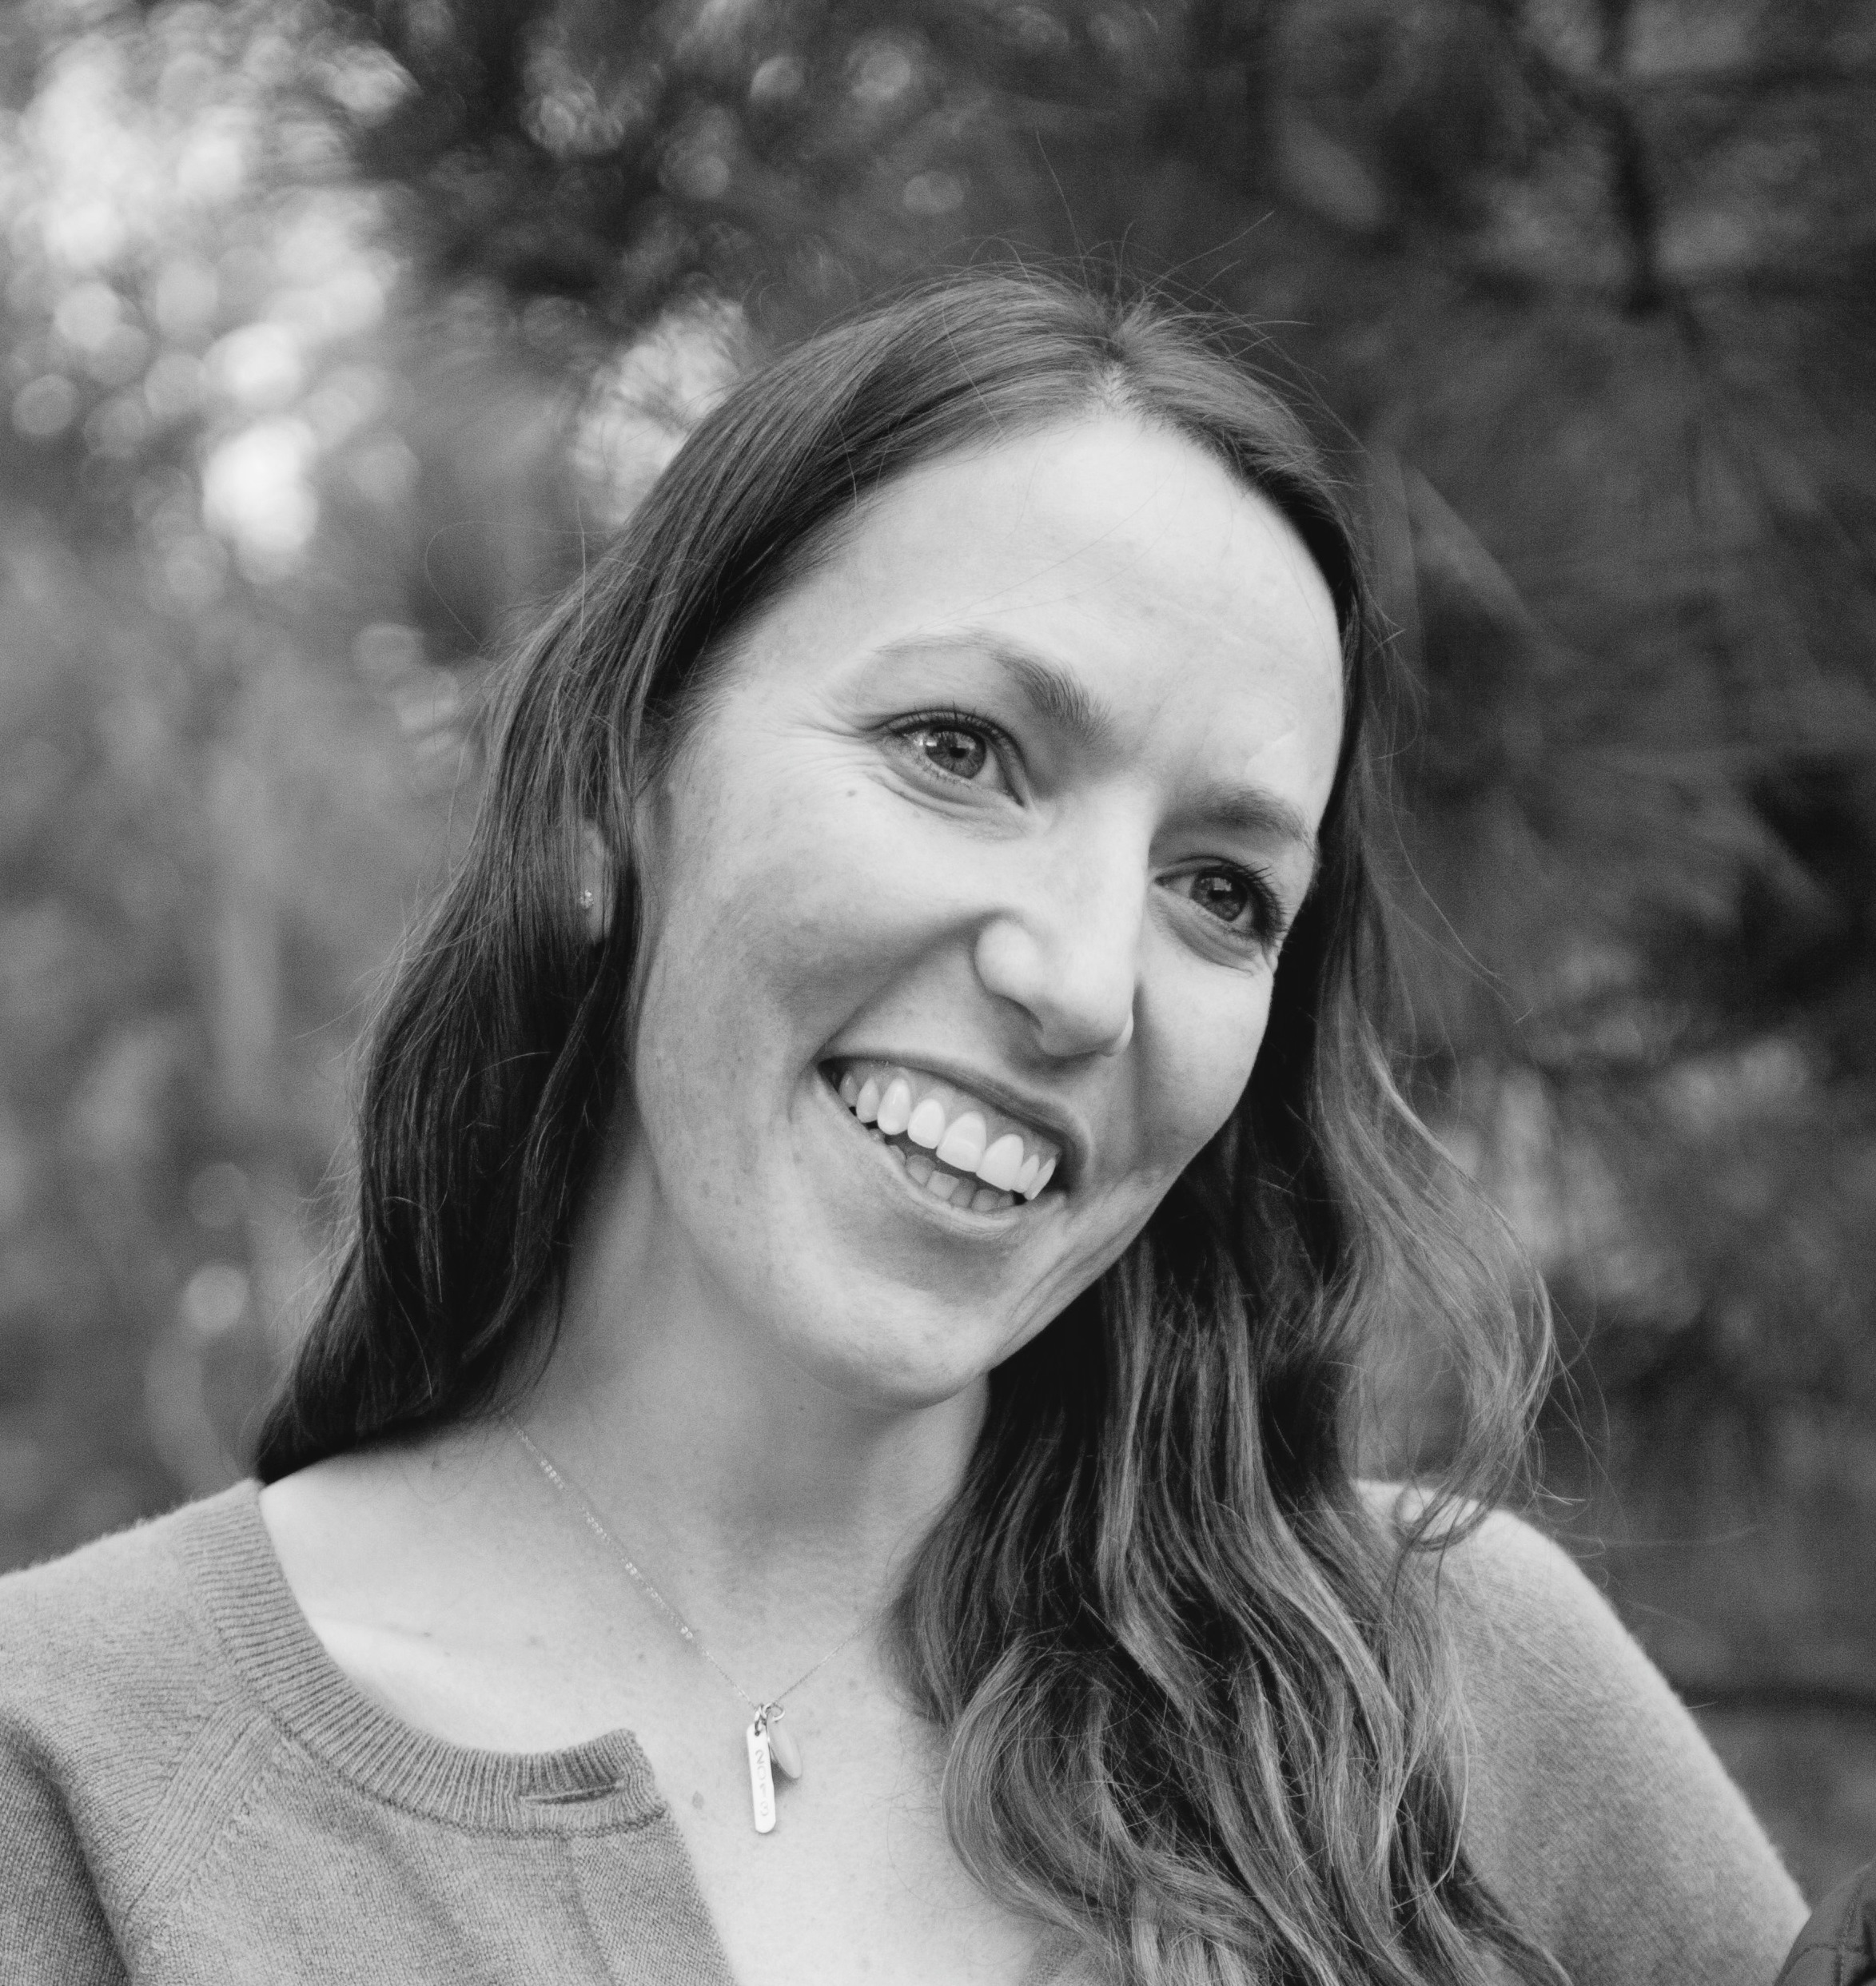Bre Owens (Point Blue Conservation Science & Cobblestone Ranch)
“ thanks for Summit support & participation
Recognize Bill Sanguinetti’s leadership
“

10 Year Milestone & Look Forward
The Coalition celebrated its 10th Anniversary in Sunol, the backdrop for the first meeting of environmentalists, ranchers and resource professionals from federal and state agencies. At this meeting of former foes in the summer of 2005, participants drafted a resolution documenting common ground for the conservation of the rangeland.
List of accomplishments to date… reaffirmed statewide interests. Statement of purpose

What’s ahead: focus on more forums and other outreach, consideration to become 501c3, enrich financial support and participation among Signatories CRCC is interested in conducting other tours in cooperation with its Signatories to build understanding and working relationships. What’s your idea?

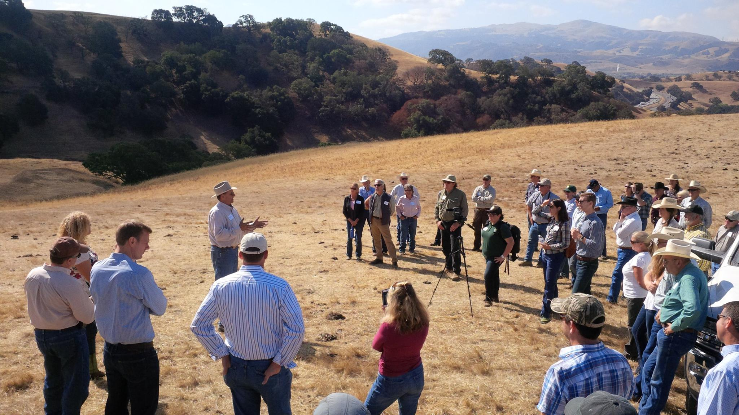

- Chair Message -a couple of paragraphs. reaffirmation of statewide interest; focus on outreach; perhaps include the Statement of Purpose.
- photos
- List Steering Committee

STEERING COMMITTEE.

Vicky Dawley,Co-Chair, Tehama Resource Conservation District
Mark Rockwell, Co-Chair, Endangered Species Coalition
Bill Rankin,California Cattlemen’s Association (CCA)
Bill Sanguinetti,CCA
Carissa Rivers, Audubon California
Casey Stone, California Farm Bureau Federation
CeCi Dale-Cesmat, Natural Resources Conservation Service
Dan Macon, California Wool Growers Association
Dave Forrest,Institute for Ecological Health
Joan Keegan, Sierra Nevada Conservancy
John Kleinfelter, California Dept. of Fish and Wildlife
Justin Oldfield, California Cattlemen’s Association
Karen Buhr, California Assoc. of Resource Conservation Districts
Kim Delfino,Defenders of Wildlife
Lesa Carlton, California Woolgrowers Association
Mark Kramer,The Nature Conservancy
Matt Hamman, US Fish and Wildlife Service
Michael Delbar,California Rangeland Trust
Pablo Garza,The Nature Conservancy
Pat Kirby, California Cattlemen’s Association
Noelle Cremers, California Farm Bureau Federation
Renata Brillinger, California Climate Agriculture Network
Robert Parkhurst, Environmental Defense Fund
Sheila Barry, University of California Cooperative Extension
Tom Hedt, Natural Resources Conservation Service
Bre Owens,Point BlueConservation Science
Pelayo Alvarez
Conservation Director
pelayo@carangeland.org

The California Rangeland Conservation Coalition builds relationships that promote rangelands and private ranching through outreach and education, participation in research, and facilitation of conversations to reduce barriers to ranching and conservation and to make new opportunities to achieve the goals of the Rangeland Resolution.

2015 On Ranch Conservation Tour – Cattle, Conversation and Community, Too
A small group of conservationists joined Point Blue Conservation Science and California Rangeland Conservation Coalition to tour four Northern California ranches that are engaged in multi-benefit collaborative conservation projects. Through discussions with landowners and numerous speakers, participants from various conservation groups gained valuable insights into the opportunities and challenges of ranching with conservation in mind. Speakers included: Burt Bundy; Tony Turri; Joe Silveira, Wildlife Biologist, U.S. Fish & Wildlife; Larry Forero, UC Cooperative Extension; Kathy DeForest; Aaron Albaugh; Russ Hawkins, a private timber operator; Todd Swickard; Jack Hanson; Tim Koopmann; Ken Collum, Bureau of Land Management; Mark Shaffer, Greenleaf Power; and Bre Owens.
These ‘tourists’ traveled over 300 miles together through four counties, enjoying two days and 3 nights of home-cooked meals and lodging provided by ranchers. Tour sponsors included Fall River/Big Valley, Intermountain, and Lassen Cattlemen and CattleWomen, Lassen Land and Trails Trust, Abernathy Ranch, Willow Creek Ranch, DeForest Livestock, Cobblestone Ranch and many ranch hosts and speakers.
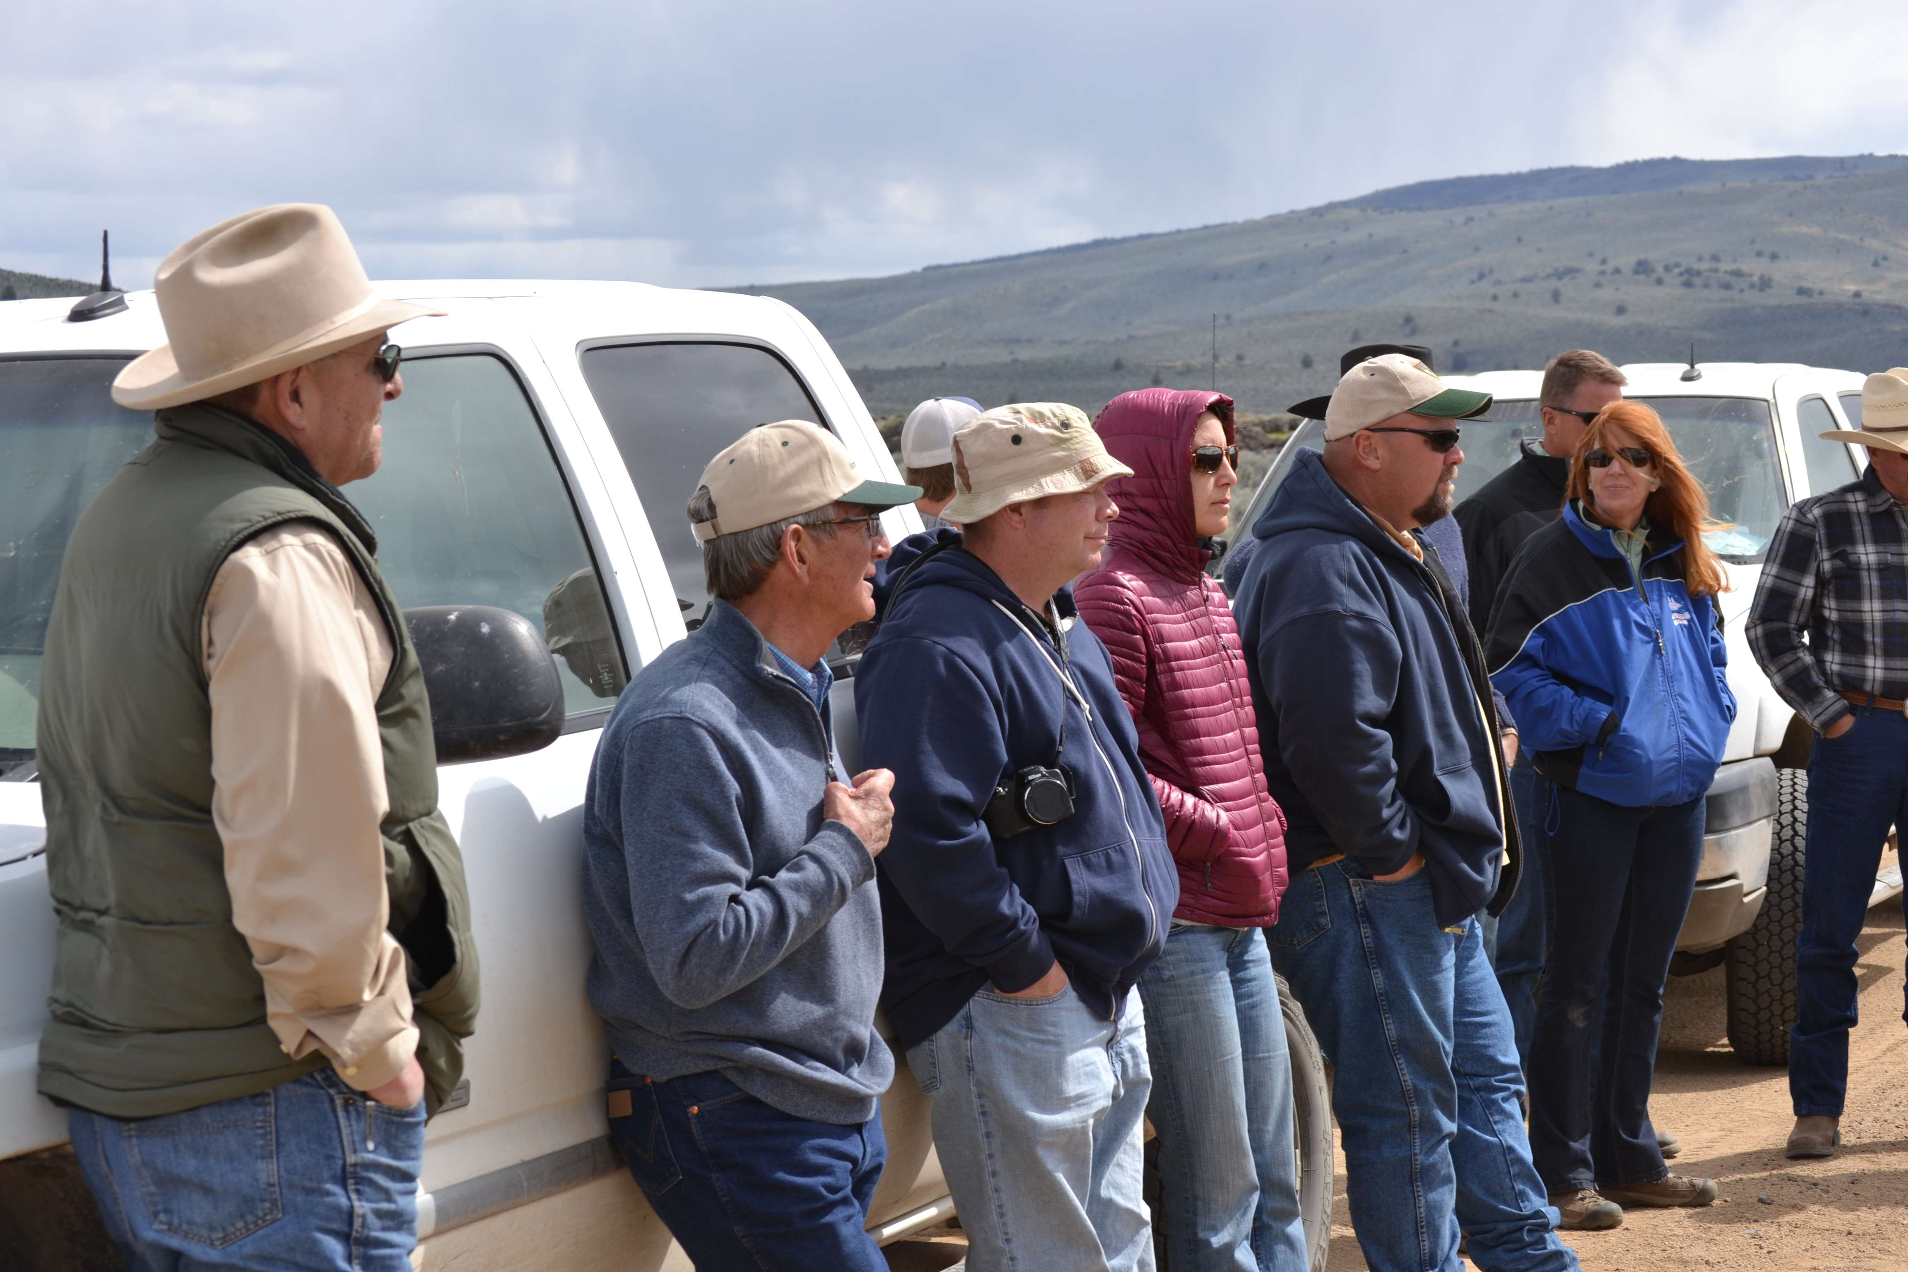
Tour participants agreed that ranchers and other rangeland stakeholders need to talk together more about these and other complex issues that impact ranching viability and voluntary conservation efforts. “Point Blue and CRCC are leaders in filling this void by fostering communication between consumers and producers with conservation being one of the important common threads,” said Todd Swickard, Five Dot Ranch. Bruce Ross, District Director for Assemblyman Brian Dahle learned a lot “through the sidebar conversations as people with common interests got to meet.” Tim Koopmann, Koopmann Ranch also emphasized the need for these opportunities - and for the California Rangeland Conservation Coalition.
The main takeaways for the non-ranchers were a better understanding of the complexities of ranching and conservation, and a heightened respect for the ranching community itself. They expressly want to learn more about ranching and about the ranching community. The ranchers stimulated planning for the 2016 Rancher to the City Tour to learn about conservation, Foodie and media perspectives to be hosted by conservation organizations.

Steering Committee

SHARE and READ CURRENT RANGELAND NEWS!
- Subscribe online to E-Update for current events from the Coalition and its Signatories.
- Submit content about your rangeland activities, rangeland position openings, publications and resources.
- “Friend” us on Facebook: I Love California Rangeland
Contact Coalition Director, Karen Sweet - ksweet@cattlemen.net www.carangeland.org

